Sales Reporting Tool
iTrakker

Job Aid

Table of Contents

Introduction 0

How to Login 4

How to Navigate 5

Sales and GP Tab 6

Generate Detailed Reports 7

Open Orders Tab 9

Open Orders Report 10

Customer Master Tab 12

Pricing Reports Tab 13

Drill By/Filter within a Detailed Report 16

Drill By and Filter - within a Detailed Report continued 17

Find – within a Detailed Report 18

View Options – within a Detailed Report 20

Snapshot – within a Detailed Report 20

Customized Reports 21

Save as – Generate the same Customized Report Automatically 25

Print – within a Detailed Report 27

Save and Export Reports 28

Drill By/Filter within Detailed Reports .14

Find 16

View/Snapshot 17

Customized Reports 18

Save as – Generate customized reports automatically 22

Print 24

Save and Export 25

Introduction
This Job Aid contains Quick Reference guides to help you better understand how to navigate the iTrakker application.

How to Login
- To access iTrakker go to Inside.Carefusion.com: http://inside.carefusion.com/myteam/USSalesandSupport/Pages/home.aspx
- Click the iTrakker (SIT & AirLife™) Login button
  - iQuote and iTrakker are located in the same area on separate tabs
- SAP username or password is required (usually only required on the first daily login)
  - VPN is required.

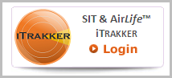

- Login to SAP Portal
- Select the Business Intelligence tab
- Select iTrakker from the Sales & Contracts menu options

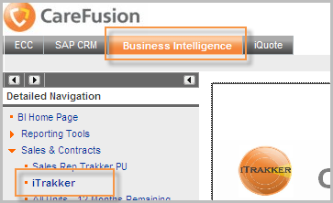

How to Navigate
- In general, there are four tabs (located at the top of the dashboard):

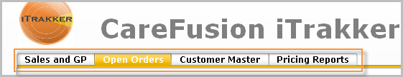

- Overview:

- Sales and GP Tab

  - There are six report button options in the Sales and GP tab: SAG, Product Hierarchy, GPO, IDN, Vendor, Sales Rep

- Open Orders Tab

  - There are five report button options in the Open Orders report: SAG, Material, GPO, IDN, Sales Rep

  - The Open Orders report button is located at the bottom of the dashboard

- Customer Master Tab

  - This button generates a list of the Sales Rep’s customers

- Pricing Reports Tab (This tab is in development.)

  - Price by Material – view contract pricing of a specific material for all customers

  - Price by Sold To – view contract pricing of all materials for a single customer

  - Price Expiration Detailed Report – view pricing contracts that will expire within 120 days

  - Material Master Price List – view existing pricing for all materials

Sales and GP Tab
- There are six report options in the Sales and GP tab:

- SAG

- Product Hierarchy

- GPO

- IDN

- Vendor

- Sales Rep
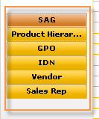

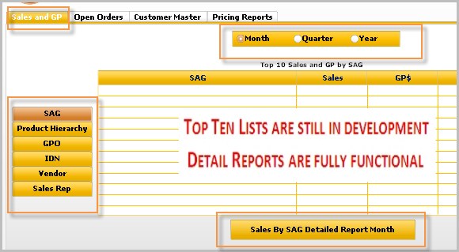

Generate Detailed Reports
- To see Detailed Reports:

- Select the Sales and GP tab (located at the top of the dashboard – first tab)

- Select the appropriate Sales and GP button (left column report options)

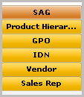

- Select the time parameter – month, quarter or year

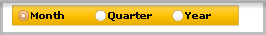

- Click the detailed report button at the bottom of the screen. The report displays in a new window.

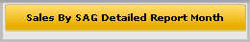

Notice: There are tabs at the bottom of each report generated.

- Each Sales and GP detailed report features a Materials tab.

- To see the equivalent of the daily sales report (for direct sales only):

  - Select the Sales and GP Tab

  - Select the SAG button

  - Select the time parameter option button

  - Click the Sales by SAG Detailed Report button

  - Select the Materials tab (located at the bottom) 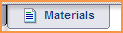

Notice: Reports are displayed with Sales, GP$, Margin for the selected time parameter. The example below is listed by month.

- Scroll to the right (to the end of the report) to see the Last 12 Months data
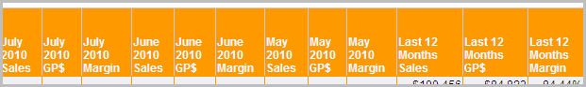

Open Orders Tab
- There are five report button options in the Open Orders report:

  - SAG

  - Material

  - GPO

  - IDN

  - Sales Rep

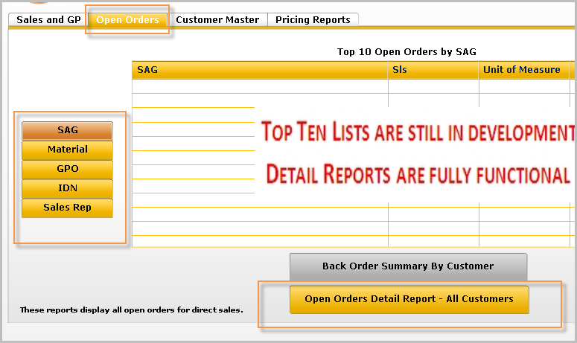
Note: To generate detailed reports, follow the same available/applicable steps:
1. Select the Open Orders Tab
2. Select the appropriate report button
3. Select the appropriate output option button

Open Orders Report
- The Open Orders Detailed Report – All Customers button is located at the bottom of the dashboard

1. Select the Open Orders Tab
2. Select the appropriate report button
3. Select the Open Orders Detailed Report – All Customers button

- The Open Orders Detailed Report:

  - Shows all orders placed but have not been fully processed to show up on the Sales and GP report (This does not mean there is an issue with the order)

  - Provides the field with more visibility and reduces the need to call Customer Service

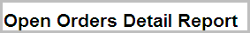

- The Open Orders Detailed Report – All Customers

Definitions:

- Billing Blocks

  - The order has shipped but we are unable to generate the invoice due a variety of reasons. The vast majority is the price is below floor and Customer Service must manual check each one of these. This slows down the process. These will be processed once the information is verified. The possible impact to the customer is a delayed invoice, but no impact to deliver of product.

- Open Orders

  - The order has been placed, but not processed. This does not mean there are issues with the order. It is more of a timing issues and calling customer service will not speed up the process. They are included in the report so sales can see we have received the order.

- Partial Shipment

  - The whole order was not filled.

- Shipped not Billed

  - A timing issue. Customers with FOB destination have a delay between when we ship and when we drop the invoice. These are on the report to let sales know the order has been shipped, but is not on their Sales & GP report yet. No action required by sales. These will automatically book when estimate destination is reached (usually within 3 days).

Customer Master Tab
- The Customer Master tab contains one button:

  - Customer Master List

- The Customer Master Report contains information such as:

    - SAG name and number

    - Sold-to address

    - Customer groups (Affiliates, distributor, hospital, etc.)

    - Customer class (State/local, non-government, Dept. of Defense, etc.)

    - Industry codes (Acute care, HMO, industrial, pharmacy, etc.)

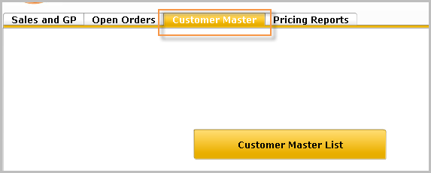

Notice: There are tabs located at the bottom of the report
- Users can view the Customer Master Report by Sold-to or Ship-to information

Pricing Reports Tab
- Pricing Report options include:

  - Price by Material – view contract pricing of a specific material for all customers

  - Price by Sold To – view contract pricing of all materials for a single customer

  - Price Expiration Detailed Report – view pricing contracts that will expire within 120 days

  - Material Master Price List – view existing pricing for all materials

- To Price by Material
  - Select the corresponding button > Enter a material number

- To Price by Sold-to
  - Select the corresponding button > Enter a customer number

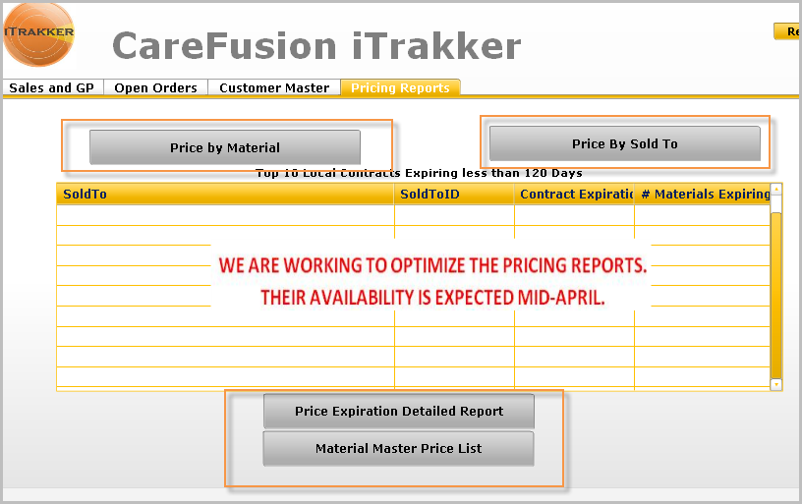

- Pricing Report Hyperlinks

- Clicking the hyperlink opens another report

- Clicking the Sold-to Number link in a Pricing Report by Material opens a Sales Usage History report in a new window

- Clicking a Material# link from the Material Master Price List opens a Rolling 12 Month Sales History Data report for the material selected

Notice: For some pricing reports, you are prompted to enter a parameter before running the report.

- Queries - to perform a material query:

  - Click the Refresh Values button to see a list of all Material Key values
    - To search for a key, enter information in the search pattern field and click the binoculars button
    - Use the wildcard (*) to search using partial information

  - Enter the appropriate information in the Enter Material Key field by selecting the material key and clicking the transfer button or by typing it into the field
    - To remove information from the material key field, click the left transfer arrow or select the information and press [Delete]

  - Click the Run Query button – the Pricing Report by Material displays

Drill By/Filter within a Detailed Report
- Once a detailed report is launched, it is possible to “drill” into the information through several layers of objects as well as filter the information to different views

Reminder:
To generate detailed reports, follow the same available/applicable steps:
1. Select the appropriate tab – For example, Sales & GP tab
2. Select the appropriate report button – For example, SAG
3. Select the appropriate time period
4. Select the appropriate output option button

Drill By and Filter - within a Detailed Report continued
- To Drill By:
  - Right-click on the name
  - Select Drill By
  - Select the option of choice
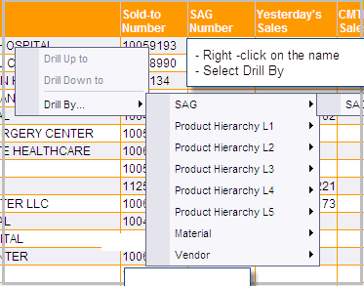

- To Filter a Report:
- Click the icon to filter the report (located towards the top left corner of the report display)

- Select the filter option of choice
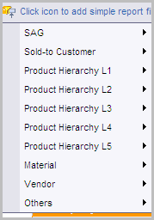

- Once the filter option is selected, you can drill further into the data
- Select the Arrow Down option to drill further into the first filter

Find – within a Detailed Report
- To Find information
  - Select the binoculars icon
  - Type text in the Find box
  - Select the Find Next button
  - Notice Options for finding information

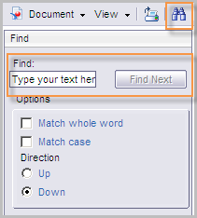

View Options – within a Detailed Report
- To View the reports in different modes
  - Select the View arrow drop-down button
  - Select the preferred view mode

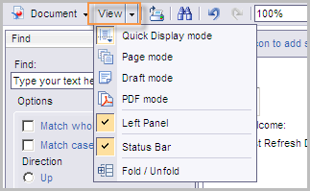

Snapshot – within a Detailed Report
- The Snapshot function enables you to take a snapshot of a report
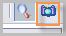

  - A copy of the report is placed on a new tab located at the bottom of the report on the All tab next to the Materials tab reports

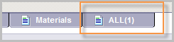

Customized Reports
- To generate Customized Reports, settings must be set as Interactive.
DO THIS ONCE:
- To activate the customized report settings, do the following:
  - Go to the Business Intelligence Tab > Reporting Tools > BO Infoview > Preferences > scroll down to Web Intelligence
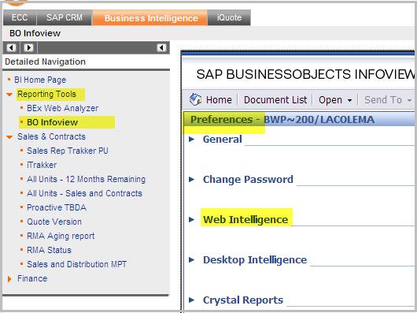

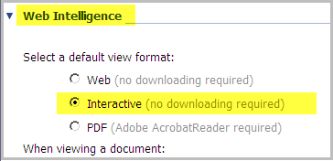

  - Select the Interactive Option
  - Select OK

- To generate a Customized Report:
  - Go to iTrakker and run a detailed report of choice

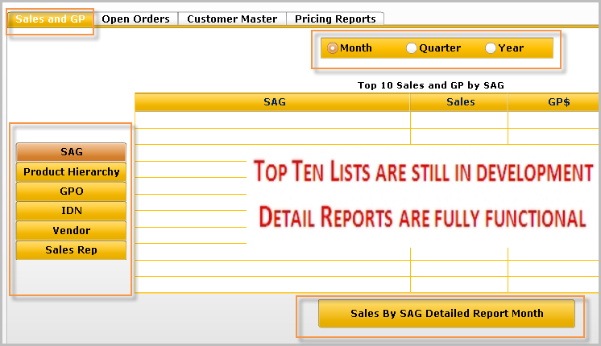

NOTICE: Once settings are set as Interactive, the Available Objects column and icons will be displayed on the left side of iTrakker.

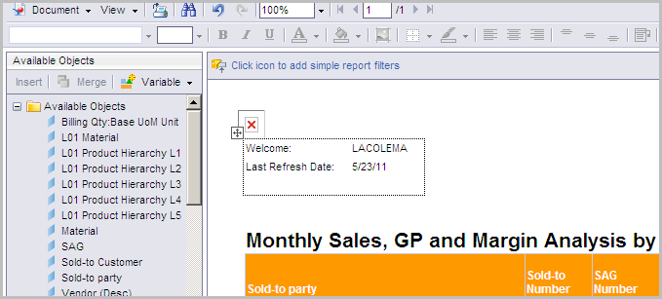

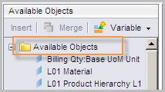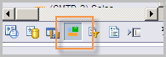

  - Review the Available Objects section (scroll down to see all available objects)
    - In general, the Blue icons are Text values, the Orange key figures are numbers and the Green Diamonds are key values

  - Select the information you are adding to the report, by clicking on the item of choice – (select the item, hold the left mouse down)

  - Drag and drop the item to the report

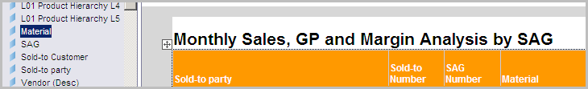

Note: It is important to drop data towards the left side of reports. The right side includes data/numbers only.

- To adjust the columns:
  - Right-click on the column title
  - Select the option of choice (ex: notice you can remove a column)

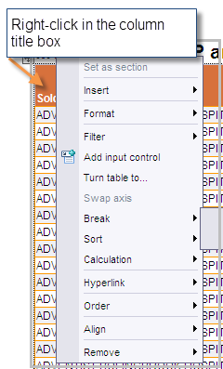

Save as – Generate the same Customized Report Automatically
- The Save as function enables you to save a favorite customized report in the system and have it generated automatically on a regular bases

  - Select the Document arrow down option
  - Select Save as > The Save as screen displays

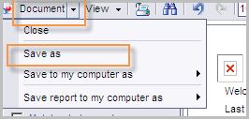
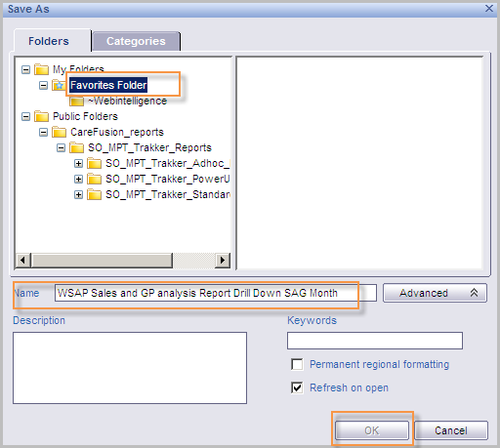
  - Select the Favorites Folder
  - Name the Report
  - Click OK the button

- To Access the saved as - regularly generated customized report:
- Go to Business Intelligence > Reporting Tools > BO Infoview
- Select My Favorites

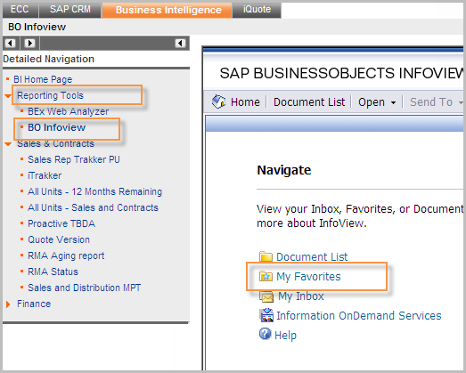
- Select the report of saved report of choice

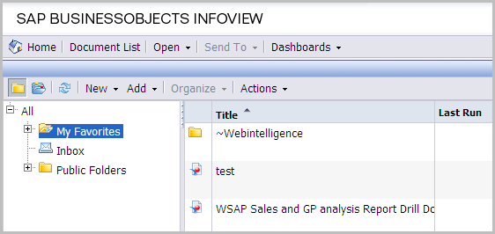

Print – within a Detailed Report
- To Print a report – The print option exports the report to PDF for printing
  - Select the Print icon button
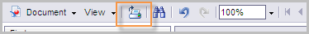
  - Select Open (to view the report) – The window below opens.
  - Select the report of choice from the left column – All, Sales, GP$, Margin, Materials
  - Select the print button

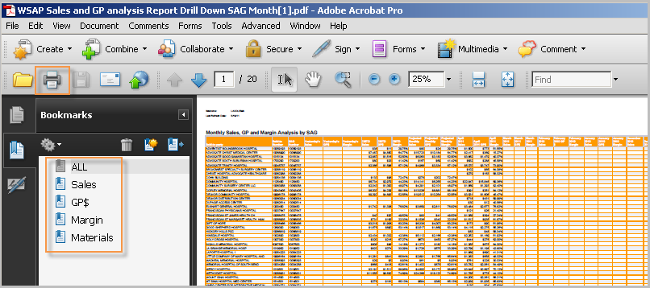

Save and Export Reports
- To export a detailed report to an Excel spreadsheet, Excel 2007 must be installed on the computer

- To download and save the current (active) tab:
- Click the Document drop-down arrow
- Select Save to my computer as
- Select Excel > The File Download dialog box displays
- Click Save > The Save As dialog box displays
- Browse to locate where you would like to save the report
- Click the Save button > When finished saving, the Download Complete dialog box displays
- Click the Open button to work on the report in the Excel format

